**Offer of Conjunction Agreement or Referral fee**

Date: 30th March 2017

From: Gerard Payne Pty Ltd

Contact Details: m 0407 972 234 e [gerard@nswrrb.com](mailto:gerard@nswrrb.com)

To: (please infill your agency)

Office address:

Contact Details:

**CONJUNCTION ARRANGEMENT**

Vendor: Harman Kooindah Property No. 2 Pty Ltd

Property Address (s): Kooindah Waters – pdf price schedule attached.

The agreed conjunction fee will be as follows: -

3 % + GST of Sales Price paid to (please infill your agency) **OR A**

1% + GST Referral fee for introducing the prospective buyer, before the buyer is dealing with our appointed local agents at Wyong.

**Signature of Principal / Director**

x............................................................................ Date:

**x (please print name)**

**Signature of Vendors Agent:**

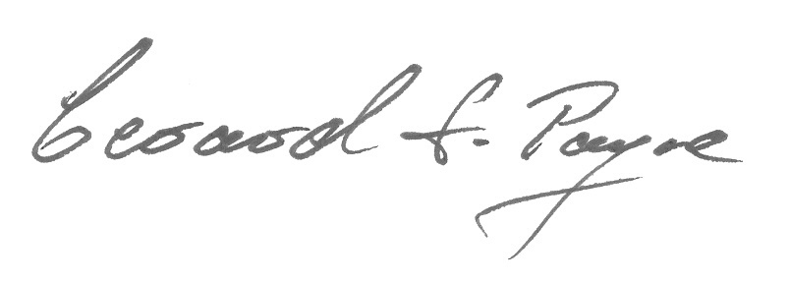

.......................................................................... Date: 30th March 2017

**Gerard Payne**

**NSW RRB**

**Valuation. Broker. Agency**